

Macquarie University

Faculty of Science and Engineering
School of Computing

COMP8230
Mining Unstructured Data
Session 1, 2026

Assignment 1

Byunghyun Hwang
48764388

Submission Date: 03/27/2026

Executive Summary
Traditional invasive methods for monitoring liver health, such as blood tests, are inconvenient for frequent and real-time tracking. To address these limitations, this report introduces a multimodal non-invasive liver health monitoring system utilizing a smart patch, a smartwatch, and embedded sensors. This system integrates sweat, arterial pattern, and motion data analysis to provide comprehensive information, enabling users to regularly monitor their liver health. Due to limited access to real-world sweat dataset, this study conducted a simulation using physiologically-informed synthetic data grounded in real-world clinical labels to validate the system’s operation. A multi-output Random Forest Regression model was trained to predict actual clinical invasive biomarkers (albumin, cholesterol, and triglycerides) by utilizing synthetic sweat component data (ammonia, urea, sodium, chloride, potassium, and cortisol) as input features. While the overall model performance ($R^{2}$: 0.5290, MAE: 26.71) and the prediction of triglycerides level ($R^{2}$: 0.30, MAE: 28.89) showed relatively low accuracy due to the inherent limitations of synthetic data, the model demonstrated exceptional performance for cholesterol ($R^{2}$: 0.88) and albumin (MAE: 0.22). These results suggest that the model performance can be further improved with real-world sweat data. To enhance the reliability of the sweat analysis, arterial pattern data was simulated by utilizing Photoplethysmogram (PPG) data as a proxy for mmWave sensor signals, due to the limited access to mmWave datasets stemming from their immense size and rarity, as well as functional similarity between PPG and mmWave analysis. This allowed for the visualization of arterial patterns as a supplementary indicator. The system identifies potential liver health risks when abnormal biomarker levels and arterial patterns are detected. Finally, motion data analysis (Accelerometer and Gyroscope) was simulated by utilizing a real-world fitness tracking dataset. Due to the scarcity of motion data labelled by user contexts, different exercise intensities were strategically mapped to validate the system logic categorizing user context into ‘daily life’ and ‘physical exercise.’ Specifically, the system distinguishes between contexts based on the movement structural complexity. Medium intensity data was used to represent daily life context due to its stochastic and irregular fluctuations. In contrast, heavy intensity data represented physical exercise context due to its more repetitive and stable patterns. This classification logic allows the system to distinguish between contexts and track liver health improvements specifically associated with physical exercise, which is highly recommended for liver patients.

AI Usage Statement
Generative AI (Gemini) was used in the preparation of this report for the following purposes.
- Polishing the English terminology and grammatical structures
- Refining and formatting reference list
- Designing the initial code draft for the Butterworth low-pass filter
- Generating the conceptual draft for Figure 1

Table of Contents

1.1. Problem Background 4
1.2. Sources of Data 4
1.2.1. Sweat Components 4
1.2.2. Arterial Patterns 5
1.2.3. Motion Patterns 5
2. Motivating Scenario 5
3. Problem Statement 6
4. Approach 6
4.1 Model Training 6
4.2. Data Collection 7
4.3. Real-Time Analysis 7
5. Results/Prototypes 8
5.1. Biomarker Level Prediction Simulation 8
5.2. Arterial Pattern Simulation 9
5.3. Motion Data Simulation 10
5.3.1. Noise Filtering 11
5.3.2. Context Identification 11
6. Conclusion 12
Reference 13

1.1. Problem Background
One in every 25 deaths worldwide comes from liver disease, indicating that approximately 4% of all death cases globally are caused by liver disease (Devarbhavi et al., 2023). Regarding Australia, approximately one-third of the Australian population is affected by fatty liver disease and, among all cancers in Australia, liver cancer is one of the most rapidly increasing causes of cancer death (University of Queensland, n.d.). In Australia, merely 16% of patients diagnosed with liver cancer survive beyond 5 years and most cases are potentially preventable through early identification (University of Queensland, n.d.). This implies that early detection of liver cancer is challenging since it often remains ‘silent’ until irreversible damage has occurred. Currently, liver cancer can only be diagnosed through blood tests, imaging scans, and tissue sampling (biopsy) (Cancer Council South Australia, n.d.). This means that identifying liver cancer early is particularly challenging for people who do not have regular medical check-ups. A personal clinical case involving an abnormal GGT (Gamma-glutamyl transferase) level highlights the limitations of current liver health monitoring systems. This biomarker was identified during a routine medical check-up, signaling potential liver inflammation. Although blood tests, imaging scans, and tissue sampling (biopsy) were conducted, the underlying cause remained inconclusive. Fortunately, other biomarkers were within normal ranges. Since no specific medication exists for this stage, management focused on prescribed supplements and regular exercise, which successfully led to a gradual decrease in the GGT level. This experience demonstrates that early liver stress is manageable but it is difficult to track liver health without consistent monitoring. Early identification of liver disease is highly dependent on regular medical check-ups, which can be inaccessible for many, especially those in countries with high healthcare costs. Therefore, IoT technology, integrated with non-invasive methods, must be applied to continuously monitor liver health status and identify early abnormalities before they progress into critical liver disease.

1.2. Sources of Data
For continuous liver health monitoring in everyday life, this system utilizes non-invasive sensing technologies to collect unstructured data from three primary sources.
1.2.1. Sweat Components: Biochemical data, including biomarkers and electrolyte shifts in sweat, will be collected utilizing smart patches.
Ammonia & Urea: Smart patches equipped with biochemical sensors non-invasively collect real-time data on ammonia and urea levels (Rath et al., 2024). Specifically, potentiometric and enzymatic sensors are utilized to collect ammonia and urea data, respectively (Xu et al., 2021). A significant elevation of ammonia with a simultaneous drop in urea is a critical indicator of liver disease, especially when these biomarkers deviate from the established personalized baselines (Rath et al., 2024).
Sodium & Chloride: The primary components of sweat are sodium and chloride, representing the most abundant electrolytes in sweat (Xu et al., 2021). These data are collected from sweat utilizing potentiometric sensors (Xu et al., 2021). Clinically, patients with advanced liver disease often have lower sodium and excessive water in their blood (John and Thuluvath, 2015).
Potassium: Potassium is a key biomarker used to track liver status (Kumar et al., 2025). Moreover, it is a predominant component of sweat, and its data can be non-invasively collected from sweat utilizing potentiometric sensors (Xu et al., 2021).
Cortisol: Cortisol is a key biochemical marker used to track liver status by monitoring physical stress in real-time (Kumar et al., 2025). This data can be non-invasively collected from sweat utilizing electrochemical biosensors (Xu et al., 2021).
1.2.2. Arterial Patterns: Physiological data will be collected utilizing smartwatches equipped with mmWave sensors. Rather than focusing on static diagnosis, these sensors track long-term trends in arterial wave patterns. Monitoring these longitudinal changes establishes a comprehensive baseline of the user’s vascular health, which serves to cross-verify and enhance the accuracy of the sweat analysis outcomes.
1.2.3. Motion Patterns: Movement data will be collected utilizing accelerometers and gyroscopes built into smartwatches. These sensors are used to remove signal noise caused by physical movement, thereby ensuring the accuracy of the arterial pattern data. Moreover, they identify when the user is exercising, which helps in understanding the relationship between physical exercise and liver health improvement.

2. Motivating Scenario
Liver diseases do not have significant physical symptoms until irreversible damage has occurred. Unfortunately, the possibility of recovery drops drastically once physical symptoms become apparent. This “silence” of the liver is not the only reason for prevention failure; current monitoring methods such as blood tests, imaging scans, and tissue sampling pose significant challenges. These methods are not only time-consuming and financially burdensome but also physically painful, particularly tissue sampling. These barriers frequently discourage people from seeking early medical check-ups, allowing liver damage to go unnoticed. To illustrate these challenges in a real-world context, consider a hypothetical case of an office worker. Through a regular medical check-up provided as an employee benefit, he identified that his GGT level was abnormally high due to non-alcoholic fatty liver disease (NAFLD). To improve his liver health, he consistently took prescribed liver supplements and engaged in intensive exercise. He regularly tracked his progress by visiting a hospital every six months. Although his GGT levels showed an overall decline, he encountered significant frustration since they fluctuated unpredictably between tests. Despite his access to a regular check-up, he was stressed by the uncertainty. He could not identify the specific reasons for these fluctuations. It was a challenge for him to determine which daily habits, such as dietary choices, exercise types, or work-related stress, were causing his GGT levels to spike or drop. This is where IoT technology needs to be applied to provide clinical value. If he had utilized an integrated IoT system connecting non-invasive smart patches and smartwatches, he could have monitored biomarkers in real time. By mining these continuous streams of unstructured IoT data, the system could identify the hidden patterns behind his GGT fluctuations. This would enable him to establish a personalized baseline and adjust his daily habits to manage his liver more effectively. From a business perspective, his doctor can manage his care more effectively, as mining these unstructured data patterns provides actionable insights and clinical values to improve his liver health. Based on this case, the inherent limitations of traditional liver testing still result in uncertainty even when financial barriers are removed. Therefore, the application of IoT for managing liver health not only encourages individuals to seek medical attention before liver damage becomes irreversible but also provides them with a personalized guideline to manage their liver health effectively on a daily basis.

3. Problem Statement
The fundamental problem in liver health management is the lack of continuous liver data, leading to significant information gaps between medical visits. Liver biomarkers, such as GGT levels, are highly influenced by daily habits; however, current diagnostic methods are infrequent and invasive. These limitations prevent both patients and clinicians from identifying specific triggers that cause liver damage. Since current methods miss the valuable insights provided by daily metabolic changes, there is an urgent need for proactive and continuous monitoring. Therefore, mining unstructured IoT data can be a solution to address this fundamental problem by providing real-time feedback. However, while non-invasive IoT sensors can provide continuous data, the range of biomarkers they can collect is limited. Key liver health indicators that are found through invasive methods cannot be fully replaced by non-invasive methods alone. To overcome these limitations, an integrated monitoring system is required to bridge the gap. The system can achieve higher accuracy in tracking liver health by mining unstructured IoT data from non-invasive methods and correlating it with clinical invasive data. The objective of this document is to propose an integrated liver health monitoring system serving as a supplement tool to frequently track liver health and identify the reasons for fluctuations between medical check-ups. This approach does not aim for a perfect replacement of clinical tests and still relies on invasive methods for high accuracy, while utilizing continuous clinical non-invasive data to enable more effective liver management.

4. Approach
According to the research conducted by Kumar et al. (2025), albumin, cholesterol, and triglycerides are identified as the key biomarkers for monitoring liver health. In this approach, non-invasive IoT data will be correlated with these key invasive features to overcome the inherent accuracy limitations of unstructured IoT data. Since our strategy focuses on predicting these key invasive features by utilizing non-invasive data mentioned in the “Sources of Data” section, establishing this correlation will leverage the advantages of both data types, effectively bridging the clinical gap between intermittent invasive testing and continuous non-invasive monitoring. The prediction of these key biomarkers through non-invasive data will enable both patients and clinicians to monitor the potential risk of liver disease. Although this predictive approach does not provide a definitive clinical diagnosis, it works as a proactive guide for early intervention and medical consultation before the liver is seriously damaged.

4.1 Model Training
The initial phase of this approach is to collect non-invasive sweat data including ammonia, urea, sodium, chloride, potassium, and cortisol from diagnosed liver patients. These features will then be utilized to train a predictive model, with clinical invasive data (albumin, cholesterol, and triglycerides) serving as ground-truth labels. For this approach, the Random Forest (RF) model is selected. This choice is grounded in the findings of Kumar et al. (2025), where RF demonstrated significant performance, achieving a balanced F1-score of 87% in classifying liver disease. Furthermore, RF is commonly embedded into edge computing systems due to its energy efficiency and rapid processing time (Hassan et al., 2025).

4.2. Data Collection
When a user wears the smart patch, integrated microfluidic chips naturally absorb sweat through micro-channels utilizing capillary action and transport it directly to the sensing region for analysis (Umapathi et al., 2025). Once sweat reaches the sensors, it is converted into bio-electrical signals. Then, these signals are filtered, amplified, and turned into digital data (Umapathi et al., 2025). Finally, Near-Field Communication (NFC) transmits this digital data to a smartwatch (Umapathi et al., 2025). Simultaneously, smartwatches equipped with mmWave sensors collect arterial pattern data. By utilizing reflected signals, micro-level physiological movements are captured by the system, enabling precise detection of arterial expansion and contraction cycles (Ji et al., 2025). To remove noise and fluctuations, the accelerometer and gyroscope integrated into the smartwatch detect abnormal physical patterns. These sensors act as a reference to determine whether data fluctuations represent a true physiological change rather than motion artifacts (Polvorinos-Fernández et al., 2025).

4.3. Real-Time Analysis
Once a smartwatch receives sweat data from the smart patch and collects arterial pattern and movement data, the integrated dataset is transmitted to an edge server. Edge computing facilitates offloading heavy data processing to overcome the computational limitations of mobile devices (Kong et al., 2022). As an essential component of this system, the edge server executes complex algorithms to ensure a real-time response (Kong et al., 2022). On the edge server, a Random Forest (RF) model predicts the levels of key metabolic biomarkers (albumin, cholesterol, and triglycerides) by analyzing the sweat data. Simultaneously, for the arterial data, the system utilizes signal pattern analysis to detect the expansion and contraction cycles of the artery, prioritizing real-time efficiency over heavy deep learning algorithms. Lastly, the motion data is analyzed to determine physical intensity, providing essential contextual information to validate whether the fluctuations in the sweat and arterial data represent true physiological signals or are artifacts induced by movement. Since data collection during physical exercise is essential for effective liver health management, this motion-aware validation is crucial. By integrating these multimodal outcomes, the edge server transmits the final results back to the smartwatch, informing the user if a clinical consultation for liver health is required. This integrated system is designed to ensure that each sensor complements the others, thereby optimizing diagnostic reliability.

5. Results/Prototypes
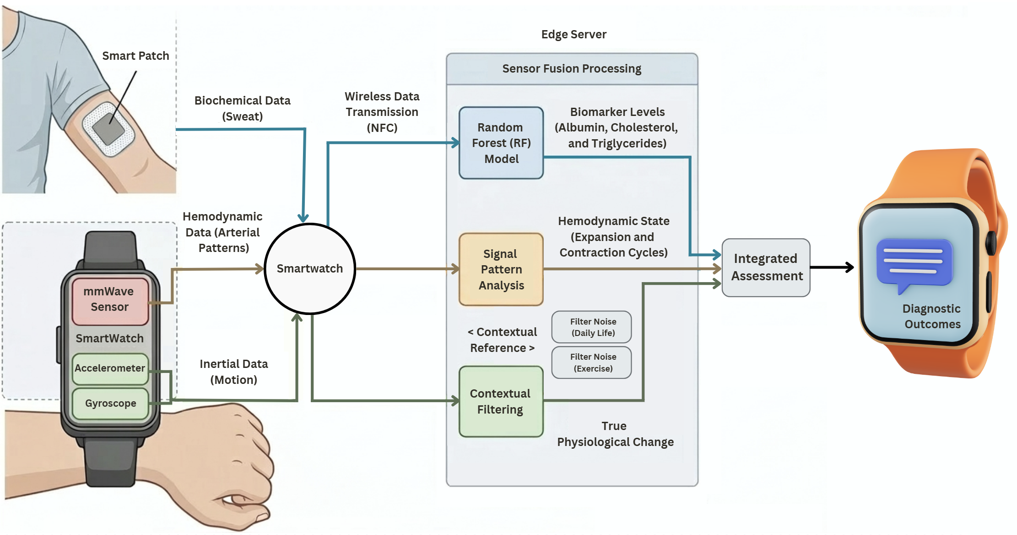
Figure 1: Non-Invasive Liver Health Monitoring System Flow
Figure 1 illustrates the comprehensive architecture of the multimodal liver health monitoring system. Biochemical data collected from the smart patch is transmitted to the smartwatch via NFC. Simultaneously, the smartwatch captures arterial hemodynamic signals and inertial motion data. All collected datasets are then transmitted to an edge server for advanced analytics. Within the edge server, a Random Forest model processes the biochemical data (sweat data) to predict key biomarkers, while the arterial signals are analyzed to monitor hemodynamic states. The inertial motion data serves as a contextual reference, allowing the system to distinguish between daily life and physical exercise contexts. The system applies adaptive noise filtering to both contexts, ensuring that the filtered data are categorized and stored separately.

5.1. Biomarker Level Prediction Simulation
A multi-output Random Forest Regression model was developed to simulate biomarker level predictions. The model was trained using the Liver Cirrhosis Stage Classification dataset (Velu, 2023), originally sourced from a Mayo Clinic study on Primary Biliary Cholangitis (PBC). The dataset was retrieved via Kaggle to obtain clinical data for albumin, cholesterol, and triglycerides from real liver patients. To bridge the gap between non-invasive sweat data and invasive clinic data, a synthetic sweat dataset was generated. The baseline values and normal ranges for sweat components were determined based on the physiological data provided by Baker et al. (2022). Weights were allocated to simulate the correlations between sweat components and the key biomarkers; for example, a weight was applied to reflect the correlation that a decrease in albumin indicates a decline in liver health. The overall performance of the model (total $R^{2}$: 0.5290) is relatively moderate, primarily due to the inherent limitations of synthetic data. However, the model demonstrates a high explanatory power for cholesterol with an $R^{2}$ of 0.88. While the $R^{2}$ for albumin (0.41) is lower, the Mean Absolute Error (MAE) is significantly low at 0.22, indicating that the predictions remain close to the actual values. In contrast, the prediction for triglycerides levels showed relatively low accuracy ($R^{2}$: 0.30, MAE: 28.89), suggesting that the complex correlation between sweat data and triglycerides is difficult to identify with synthetic data. These results suggest that the model’s performance and accuracy could be improved if it is trained with real-world sweat-blood paired data.
 | Total | Albumin | Cholesterol | Triglycerides
R2 | 0.5290 | 0.41 | 0.88 | 0.30
MAE | 26.71 | 0.22 | 51.02 | 28.89
Table 1: RF Model Performance
In terms of clinical utility, this system is designed to trigger automated clinical notices when predicted values exceed established normal ranges, based on the physiological data provided by Cleveland Clinic (2022a, 2022b, 2022c). Furthermore, it implements a longitudinal analysis by comparing current measurements with the user’s monthly and yearly averages as illustrated in Figure 2. This enables users to monitor whether their liver health is improving or if immediate medical attention is required.
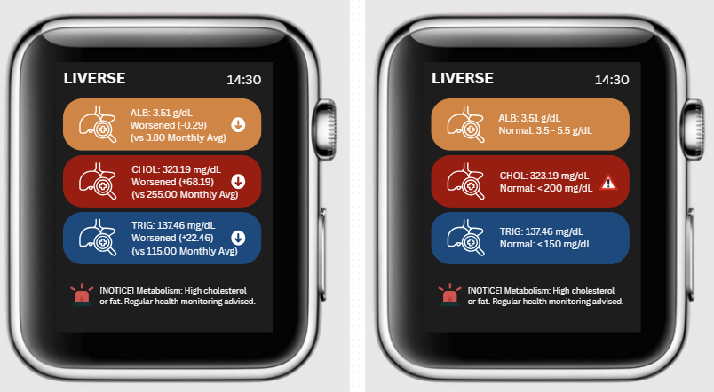
Figure 2: Monthly Status and General Status Analysis

5.2. Arterial Pattern Simulation
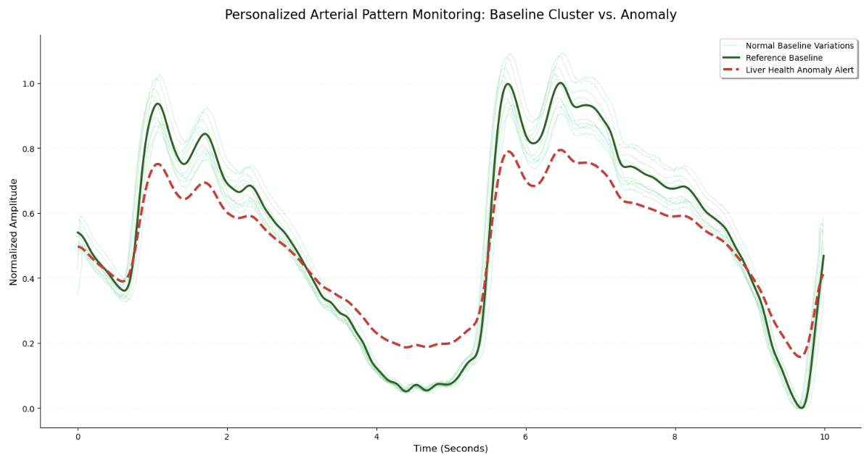
Figure 3: Personalized Arterial Pattern Monitoring Simulation
Figure 3 illustrates the simulation of personalized arterial pattern monitoring. The system collects user’s arterial patterns and compares them against a personalized baseline pattern. For this simulation, the PPG Signal dataset (Capurro, 2021) was retrieved via Kaggle to establish a representative baseline of normal blood flow. Since the clinical backgrounds of the volunteers in the dataset were not specified, these patterns are assumed to be healthy baseline references. The dataset consists of blood flow patterns measured from the index fingers of human volunteers. Although the final system utilizes a mmWave sensor, PPG data was selected for two primary reasons. First, public mmWave datasets are limited and often exceed 100GB, which is impractical for this scope of this analysis. Second, while PPG and mmWave operate on different principles, they both measure the same movement of blood vessels. Therefore, it is assumed that the shape of the patterns from both sensors remain fundamentally similar. To remove high-frequency noise, a Butterworth low-pass filter was implemented. To demonstrate the system’s operational procedure, transparent green variations and a red anomaly line were generated for comparison. In the visualization, the solid green line represents the user’s core baseline, while the multiple transparent green lines show normal daily variations. In contrast, the red line indicates an abnormal pattern where blood is not flowing properly through the liver. When the mmWave sensor detects such significant deviations, the system triggers a health alert on the user’s smartwatch as illustrated in Figure 4.

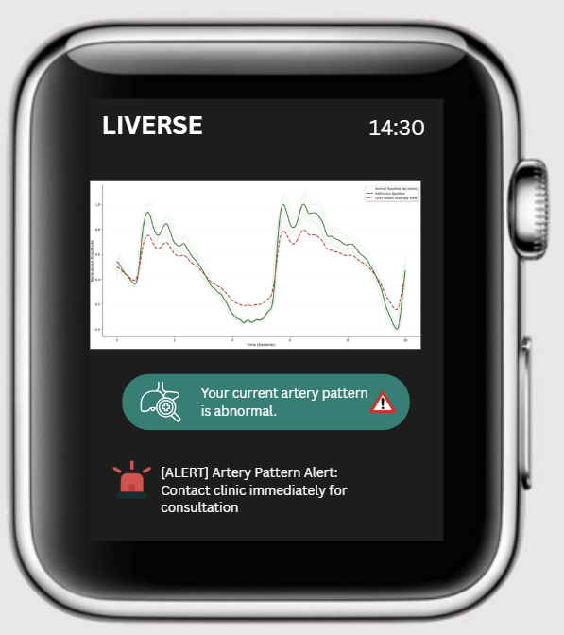
Figure 4: Real-Time Arterial Pattern Analysis

5.3. Motion Data Simulation
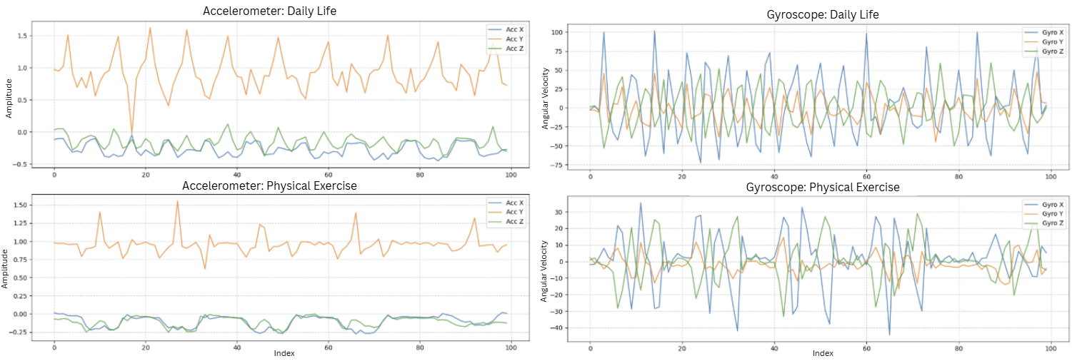
Figure 5: Motion Pattern Monitoring Simulation (Accelerometer and Gyroscope)
The motion sensors (accelerometer and gyroscope) in a smartwatch play a critical role in ensuring that liver health analysis is accurate and personalized. The system leverages dual-logic processing to acquire high-purity diagnostic pattern signals. For this simulation, the Fitness Tracker – Accelerometer and Gyroscope dataset (Jeniya, 2024) was retrieved via Kaggle to compare motion patterns between daily life and physical exercise contexts. In this dataset, ‘medium’ and ‘heavy’ intensity exercise data were utilized as proxies to represent daily life and physical exercise, respectively. This decision was based on the observation that while heavy exercise involves higher physical force, it shows structured and repetitive patterns. In contrast, daily life (medium intensity) shows more stochastic and irregular movements. Accordingly, a more sophisticated noise filtering approach is required for daily life context to remove motion artifacts.

5.3.1. Noise Filtering
The motion sensors (accelerometer and gyroscope) are constantly monitoring the user’s arm movements across X, Y, and Z axes. The system compares real-time movement with the user’s established personalized baseline movement pattern. By detecting and eliminating small and random variations, the sensors ensure that significant sweat composition data and arterial pattern data remain clean and uncontaminated for accurate analysis. As demonstrated in the motion pattern comparison, daily life patterns fluctuate more than structured physical exercise patterns (see Figure 5). Consequently, the system applies a more intensive noise-filtering algorithm to the daily life context to ensure the purity of the diagnostic signals. Specifically, the motion data serves as a control parameter for the arterial signal processing. When the system identifies a daily life context, it triggers the suppression of irregular motion artifacts.

5.3.2. Context Identification
Beyond simple noise-filtering, the sensors are utilized to identify the specific context of the user’s activity. By comparing real-time motion signals against the personalized baseline, the system distinguishes whether the user is engaged in daily activities or physical exercise. If the movement pattern fluctuates with high irregularity (as seen in the daily life context graphs), the system recognizes it as daily life. In contrast, regular and high-amplitude patterns are identified as physical exercise, and the data is specifically classified into this exercise context for tracking health progress. This classification is a critical feature, as it enables the system to track liver health progress specifically during physical exercise, rather than dismissing physiological changes as mere noise as illustrated in Figure 6. However, the current identification logic is based on the simple hypothesis that daily life activities show more complex movement fluctuations than structured physical exercise. While this is true in most cases, this simplified approach may not account for all environmental variables, and distinguishing every scenario is technically challenging. These limitations will be addressed in future work through the integration of more advanced motion sensors and sophisticated motion data processing techniques.
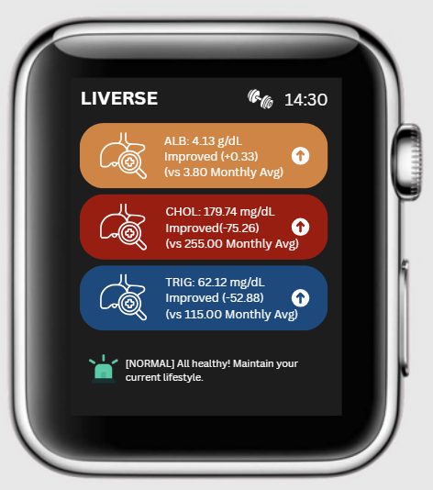
Figure 6: Physical Exercise Context Analysis

6. Conclusion
This multimodal liver health monitoring system was designed to bridge the gap between non-invasive and invasive methods of liver health tracking. To validate the system’s operation, a multi-output Random Forest Regression model was trained using a dataset that integrated clinical data from real liver patients with synthetic sweat data to predict levels of key invasive biomarkers (albumin, cholesterol, and triglycerides) for a simulation test. While the overall model performance was moderate due to the inherent limitations of synthetic data, the model exhibited high explanatory power for cholesterol and predicted albumin levels closely aligned with ground-true values. In contrast, the prediction accuracy of triglycerides was lower. These outcomes demonstrate that the model performance could be improved with real-world paired data. These predicted levels enable the monitoring of liver health status and progress based on monthly/yearly records or the general levels of the key biomarkers. Furthermore, the arterial pattern analysis was simulated utilizing a PPG proxy dataset (rather than mmWave) to enhance the reliability of the sweat data analysis. The identification of abnormal prediction levels and arterial patterns indicates potential risks of liver disease. Finally, motion data pattern analysis was simulated utilizing an exercise proxy dataset to identify and remove background noise causing data contamination. Beyond noise elimination, motion data was analyzed to classify collected sweat and arterial pattern data into daily life and physical exercise contexts. Although the motion data plays a significant role in filtering clean data and providing valuable insights, the development of advanced sensors is still required to enhance the system reliability, especially in distinguishing contexts.

Reference

Baker, L. B., Engel, M. D., & Wolfe, A. S. (2022). Sweat as a Diagnostic Tool: Biological Realities and Technological Challenges. Sports Science Exchange #226. Gatorade Sports Science Institute.
Cancer Council South Australia. (n.d.). Liver cancer (primary). https://www.cancersa.org.au/about-cancer/types-of-cancer/liver-cancer-primary
Capurro, L. (2021). PPG Signal Dataset. Kaggle. https://www.kaggle.com/datasets/lucilacapurro/ppg-signal-dataset
Cleveland Clinic. (2022a). Albumin Blood Test. Retrieved from https://my.clevelandclinic.org/health/diagnostics/22390-albumin-blood-test
Cleveland Clinic. (2022b). Cholesterol Numbers: What Do They Mean? Retrieved from https://my.clevelandclinic.org/health/articles/11920-cholesterol-numbers-what-do-they-mean
Cleveland Clinic. (2022c). Triglycerides. Retrieved from https://my.clevelandclinic.org/health/articles/11117-triglycerides
Devarbhavi, H., Asrani, S. K., Arab, J. P., Nartey, Y. A., Pose, E., & Kamath, P. S. (2023). Global burden of liver disease: 2023 update. Journal of Hepatology, 79(2), 516-533. https://doi.org/10.1016/j.jhep.2023.03.017
Hassan, U., Rehman, Z. U., Ahmad, I., & Islam, S. U. (2025). Analyzing the energy consumption of random forest and support vector machine models: paving the way for green and sustainable artificial intelligence. Discover Internet of Things, 5(100). https://doi.org/10.1007/s43926-025-00188-4
Jeniya, K. (2024). Fitness Tracker Accelerometer and Gyroscope Data. Kaggle. https://www.kaggle.com/datasets/krishujeniya/fitness-tracker-accelerometer-and-gyroscope -data
Ji, X., Dong, F., Huang, Z., Guo, X., Zhu, H., Chen, B., & Shen, J. (2025). Edge-assisted multi-user millimeter-wave radar for non-contact blood pressure monitoring. Applied Computing and Intelligence, 5(1), 57-76. https://doi.org/10.3934/aci.2025004
John, S., & Thuluvath, P. J. (2015). Hyponatremia in cirrhosis: Pathogenesis and management. World Journal of Gastroenterology, 21(11), 3197–3205. https://doi.org/10.3748/wjg.v21.i11.3197
Kong, X., Wu, Y., Wang, H., & Xia, F. (2022). Edge computing for Internet of Everything: A survey. IEEE Internet of Things Journal, 9(21), 20472-20485. https://doi.org/10.1109/JIOT.2022.3200431
Kumar, D., Bakariya, B., Verma, C., & Illes, Z. (2025). LivXAI-Net: An explainable AI framework for liver disease diagnosis with IoT-based real-time monitoring support. Computer Methods and Programs in Biomedicine, 270, 108950. https://doi.org/10.1016/j.cmpb.2025.108950
Polvorinos-Fernández, C., Sigcha, L., Borzì, L., Cardoso, P., Costa, N., Costa, S., López, J. M., Asensio, C., De Arcas, G., & Pavón, I. (2025). Diagnosis of resting tremor in Parkinson's disease using accelerometer and gyroscope sensors built into a smartwatch. In Biomedical Engineering Systems and Technologies (pp.460-481). Springer, Cham. https://doi.org/10.1007/978-3-031-96899-0_26
Rath, R. J., Herrington, J. O., Adeel, M., Güder, F., Dehghani, F., & Farajikhah, S. (2024). Ammonia detection: A pathway towards potential point-of-care diagnostics. Biosensors and Bioelectronics, 251, 116100. https://doi.org/10.1016/j.bios.2024.116100
Umapathi, A., Alshamsi, M., & Al-Qutayri, M. (2026). Smart patches for healthcare industry: a review of emerging technologies, challenges, and developmental opportunities. BioMedical Engineering OnLine, 24, 12. https://doi.org/10.1186/s12938-025-01485-3
University of Queensland. (n.d.). The silent threat in fatty liver disease. Institute for Molecular Bioscience. Retrieved March 7, 2026, from https://stories.uq.edu.au/imb/the edge/inflammation/silent-threat-in fatty-liver-disease/index.html
Velu, A. (2023). Liver Cirrhosis Stage Classification. Kaggle. https://www.kaggle.com/datasets/aadarshvelu/liver-cirrhosis-stage-classification
Xu, J., Fang, Y., & Chen, J. (2021). Wearable Biosensors for Non-Invasive Sweat Diagnostics. Biosensors, 11(8), 245. https://doi.org/10.3390/bios11080245

